NEWSLETTER 4
RECYCLE FOR KENILWORTH
March 2024 written by May Lau
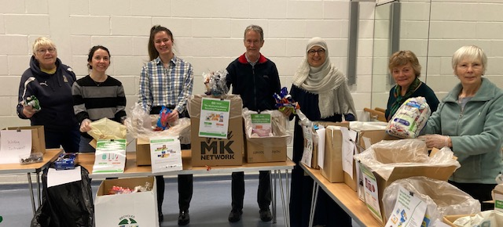
On Saturday 16th March 2024 we held our Sorting Party at the Kenilworth Centre (tKC) Upper Hall. I attended with (left to right) Sheila, Carla, Cheryl, Cllr James Kennedy, Faryal, Kit Lawry, and Janet.
Sandwiches supplied by WEDGE - a Plastic Free Kenilworth Business Champion.

THANK YOU very much for the donations and public drop off from Tracey and Sally and all participants’ hard work today. We have now cleared all the backlog on collected materials and can concentrate on clearing all the collected and dropped off materials every month.

Everyone who has pledged to come back to help has been awarded a RECYCLE FOR KENILWORTH tote bag. Please do come to our next Sorting Parties to receive yours.

We also shared information about latest developments about ‘where to recycle what’:
- Empty crisps packets – please continue to give to us and when TerraCycle informs me of stopping the free recycling payments to Charities, we will recycle them with other Soft Plastics at Supermarkets.
- Empty toothpaste tubes and glue stick tubes – I have received confirmation from Cllr Will Roberts that if the products state to ‘recycle’, do put them in with Dry Mixed Recycling (blue-lidded bin). It is always good practice to empty the tubes and rinse out as much residue as possible and dry off before putting in the recycling bin.
- Not all supermarkets accept soft plastics to be recycled, and not even big Supermarkets nor Council Recycling Centres accept a full range of hard-to-recycle plastics. I have circulated a poster (enclosed at the end of this Newsletter) to show the range of materials RECYCLE FOR KENILWORTH accepts and sort to send to TerraCycle to claw back some cash to donate to tKC to help provide Mental Health Wellbeing Programmes for Kenilworth Youths.
- I shared a link to the Gillette + TerraCycle website to register for recycling all brands of Razors and Razor Blades with a pre-paid envelope from Gillette. Watch the process on my
YouTube Channel : https://www.youtube.com/watch?v=0xDFRsyMgzc
- There is a brand called the Two Farmers hand cooked crisps (bought from WEDGE in 40g size) packages their crisps in 100% plastic free home and industrially compostable bags.
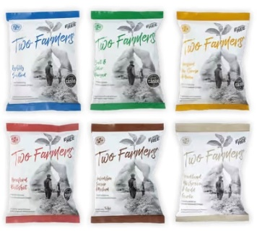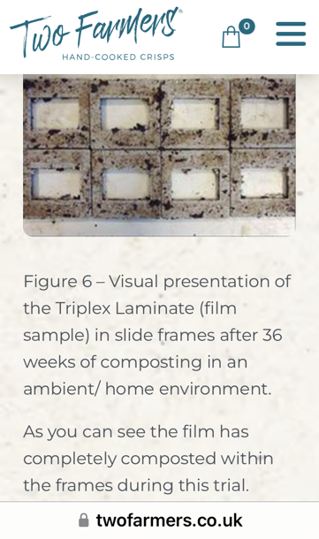
- The sorting group would like to re-iterate to everyone that our purpose is to include those who want to recycle appropriately and to claw back some cash for charity services for Kenilworth. We do not replace any of the Council’s kerbside collections. Please kindly leave out food waste, food trays, tetra-pak cartons or even the contents of the hoover in our collections and/or drop-off’s. Many thanks.
On Sunday 17th March 2024, Sheila and I attended the 10,000 Sunflower Launch at the Cubbington and Lillington Environmental Action Now (C.L.E.A.N.) Event organised by Matt Black and had a prototype run of the RECYCLE FOR KENILWORTH Recycling Sorting Game for 5+, 11+ and Adults. 150+ people visited the event between 13:00 and 16:00. I have very much enjoyed the enthusiasm of the children and gained early support from Lillington residents who are interested to come to our Sorting Parties in the future.
Should you know of any school who would like me to run the game at school fetes this Summer, please let me know soonest. Thank you.

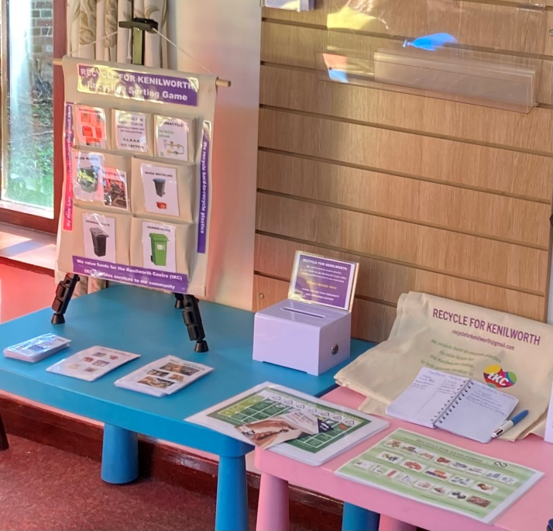

INVITATION– R.S.V.P.: RECYCLE FOR KENILWORTH Sorting Party at tKC, Upper Hall
On Saturdays, 12:30 – 16:30:
April 20th – Coventry Schools and Central England DofE volunteering
May 11th – report back from visit to Sherborne Recycling Facility - ‘what happens to our kerbside
collected mixed recycling?’ and ‘what next?’
June 15th - TBC
July 13th

Raising funds for tKC to help provide Mental Health Wellbeing Programmes for Youths in our Community.

