**Room Hire Income**

**2023 – 2024 January Predicted Room hire income**

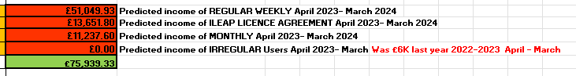

**2023 – 2024 Predicted Room hire income – updated June2023**

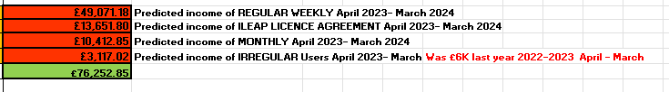**______**

**2022 – 2023 Room hire income**

**________________________________________________________________________________________**

**Occupancy Stats** - upto and including May 2023

**Occupancy Stats** – Year comparisons. Upto and including May 2023

**Cancellations/reduced hours 2022-2023:**

|  |  |  |  |  |
| --- | --- | --- | --- | --- |
| **Customer** | **Room** | **Hours p/w p/m** | **Effective** | **Cost p/m** |
| SPARK Music | Snug  Pod | 4 p/w TT  4 p/w TT | Sept ‘22 | £96  £96 |
| Kumon Kenilworth Study Centre | YR | 2 p/w  2.5 p/w | Sept ‘22 | £139  £95 |
| Kenilworth Women's Institute | LCR | 2.5 p/m | July ‘22 | £39.50 |
| Kenilworth Consort Singers | SCR | 2 p/m | Aug '22 | £20.60 |
| Kenilworth Chamber of Trade | LCR | 3.5 p/w | July ‘22 | £168 |
| Living your yoga | Hall | Reduced 3hrs pw | April ‘22 | £139.5 |
| Han Bandhu Yoga | Hall | Reduced by 1hr | Oct ‘22 | £61.50 |
| Moo Music | Hall | 1.5hrs pw | April’22 | £92 |
| Foodbabnk | SCR | 2 hrs | Sept ‘22 | £65.60 |
| Release Restore Reaslise | LCR | 1 hr | Dec ‘22 | £32.20 |
| Eiraya Wellness | SCR | 1hr biweekly | Nov '22 | £24.60 |
| Whitemans | Hall / LCR |  | Nov 22 | £807 |
| DDMIX Kate Price | Hall | 1 | Jan ‘23 | £80 |
| Diabetic Eye Screening | SCR & LCR | 7 hrs each | March ‘23 | £212.10 |
| **Drama Tota** | **LCR** | **1.5 pw** | **April’23** |  |
|  | | | **Per Annum (approx. as some are term time only)** | **£23,854** |

**Extended contract to 2023-2024:**

|  |  |  |  |  |
| --- | --- | --- | --- | --- |
| **Customer** | **Room** | **Hours p/w p/m** | **Effective** | **Cost p/m** |
| Barclays | YR | 4.5 p/w | 1 year from March ‘23 | £306 |

**New customers:**

|  |  |  |  |  |
| --- | --- | --- | --- | --- |
| **Customer** | **Room** | **Hours p/w p/m** | **Effective** | **Cost p/m** |
| Viva Theatre Arts | Hall | 3 p/w | Jan ‘23 | £1,200 |
| Inspiration Pilates | Hall | 2hrs pw | Jan ‘23 | £70 |
| Zumba Fitness | Hall | 1 hr pw | March ‘23 | £90 |
| Catherine Connan/Psychotheraphy | Snug | 1 hr pw | April ‘23 | £36 |
| U3A poetry | SCR | 4 hrs pm | Feb ‘23 | £47.2 |
| Together through Sport / Compassionate Ken. 50% charge | Court | 2hrs pw | March ‘23 | £48 |
|  |  |  | **Per Annum (approx. as some are term time only)** | **£17,393.00** |

Possible new customer Music Monkeys. LCR 3 x hrs pw Term time. Starting September 1,532.7 PA